# Due Date: By the end of the first lab session.

# 

# Description:

The purpose of this exercise is to practice Window’s simple file management tasks and go over the electronic submission on Blackboard Learn. Many of the tasks listed below require prerequisite knowledge; others will be demonstrated by your lab instructor. It is important to complete this exercise in order to be prepared for future labs.

**Task Description:**

Step 1. Log on to the lab computer using your career account.

All students should have career account to login to the computer in *ITaP* labs.

Step 2. If you are using Windows 10, search “File Explorer Options” in the Windows 10 Start Menu > click on “View” tab > under that “Advanced settings:” and have the following settings in place:

* Always show menus – *Checked*
* Display the full path in the title bar - *Checked*
* Under hidden files and folders

Show hidden file, folders or drives – *Checked*

* Hide extension for known file types -***Unchecked***

It is very important that you set these options each time you work on a programming assignment for this course.

Step 3. Click the “Shortcut to 'Home Directory' (W)” on your Desktop to navigate to the home (W) drive:

* Create a folder. Name it *CNIT155*.
* Under CNIT155 create 2 subfolders. Name them *In_Labs* and *Assignments*. The *In_Labs* folder is to store exercises you do during the lab sessions and the *Assignments* folder is to store weekly programming assignments.

Step 4. Launch Blackboard Learn on any browser, and select CNIT 155.

Step 5. Find this document by clicking on *In_Labs* link. Download this document and save it to the hard drive in In_Labs folder you created in **Step 3**. You can open the document with MS Word and print it if you prefer to work with paper.

***TIP: How to access the W drive from your personal computer at home:***

* Map your network W drive to your PC:

*This PC* 🡪 *Computer* 🡪 *Map network drive* 🡪 in the pop up window, select an alphabet for drive that is not in use, e.g. B 🡪

Under Folder 🡪  \\myhome.itap.purdue.edu\myhome\ 'Your Purdue Career Account Username’

*Step 6. Open Visual Studio 2019 to create a new project by following the below parts.*

***Part1:*** *Open Visual Studio 2019. Click on start menu and type “Visual Studio 2019” as illustrated by* Figure 1*.*

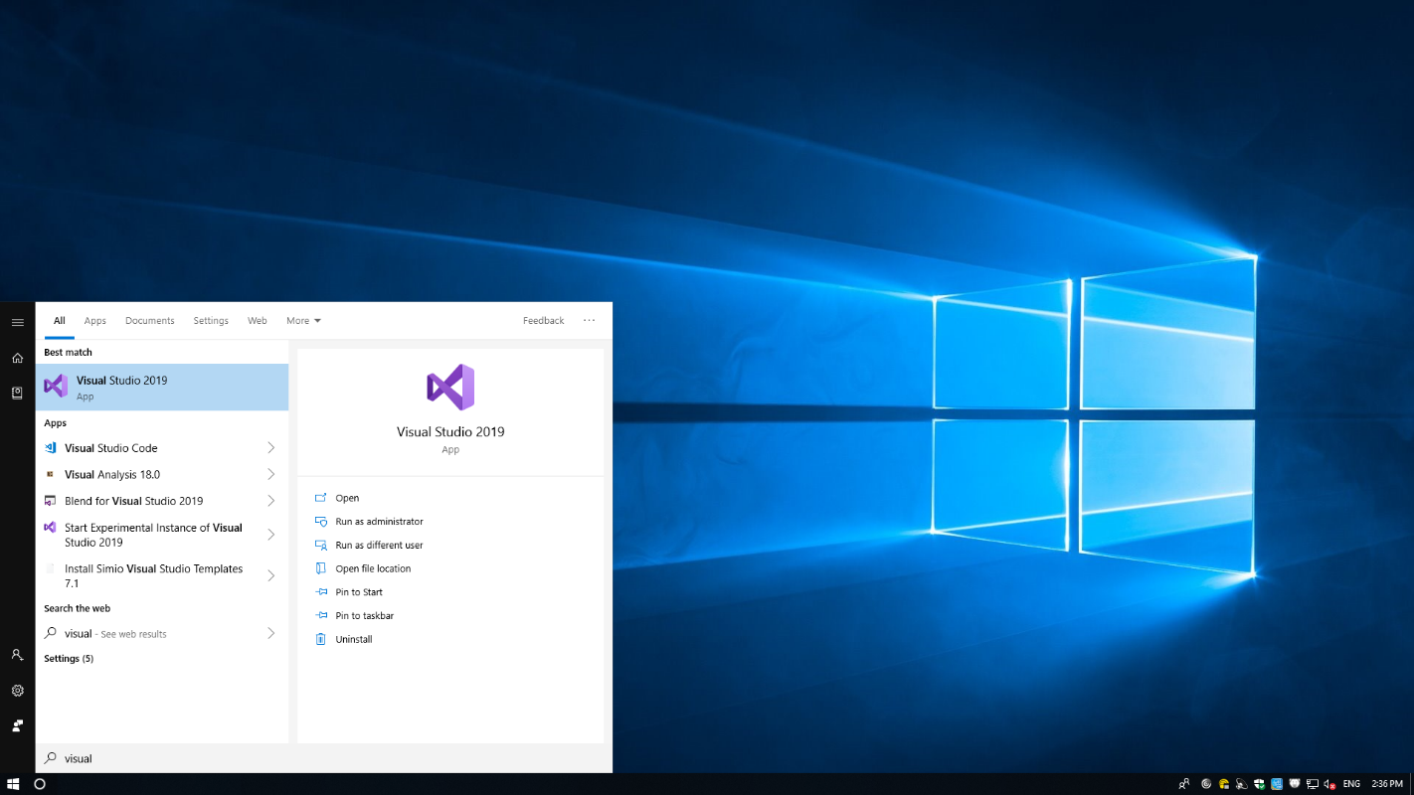

Figure 1 - Open Visual Studio 2019

**Part2:** Create new project. Figure 2 presents the starting window of visual studio. In this window click on “Create new project”.

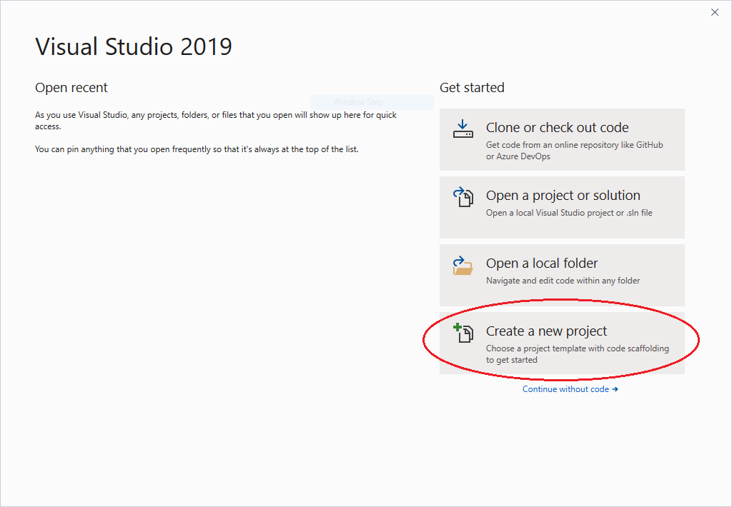

Figure 2 - Visual studio start window.

**Part 3:** As depicted in Figure 3, type “Windows Forms App” in the search textbox to select “Windows Forms App (.NET Framework)”. Then, click on the “Next” button.

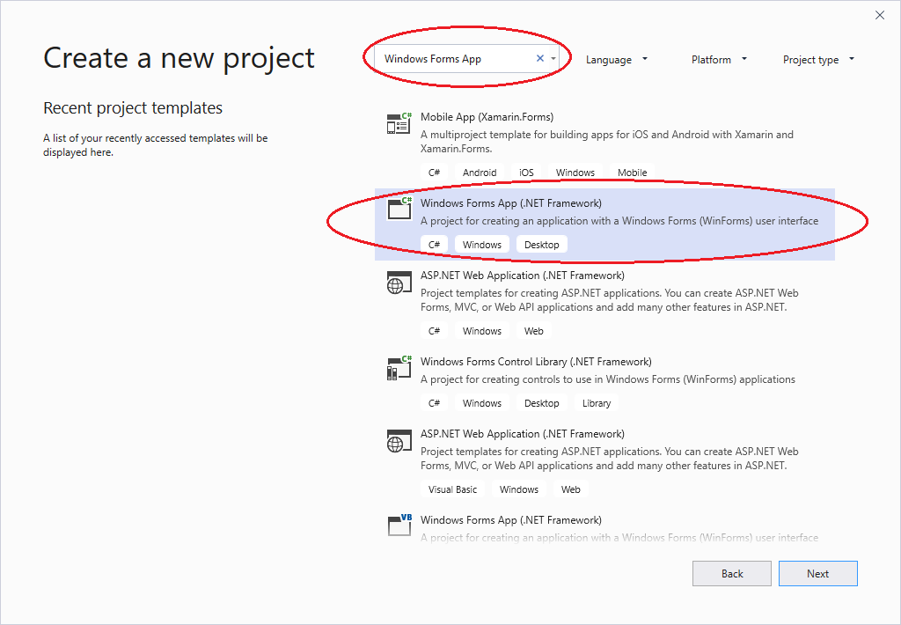

Figure 3 – Search for “Windows Forms App”

Part 4: Enter a name for the project and browse to select a location. Following Figure 4, change the name of the project to “LastNameFirstName_Inlab01”. Next, Change the Location to W drive -> CNIT 155 -> InLabs (This will save your InLabs in the proper folder on your W drive). Then, click on “Create”.



Figure 4 – Enter project name and select location.

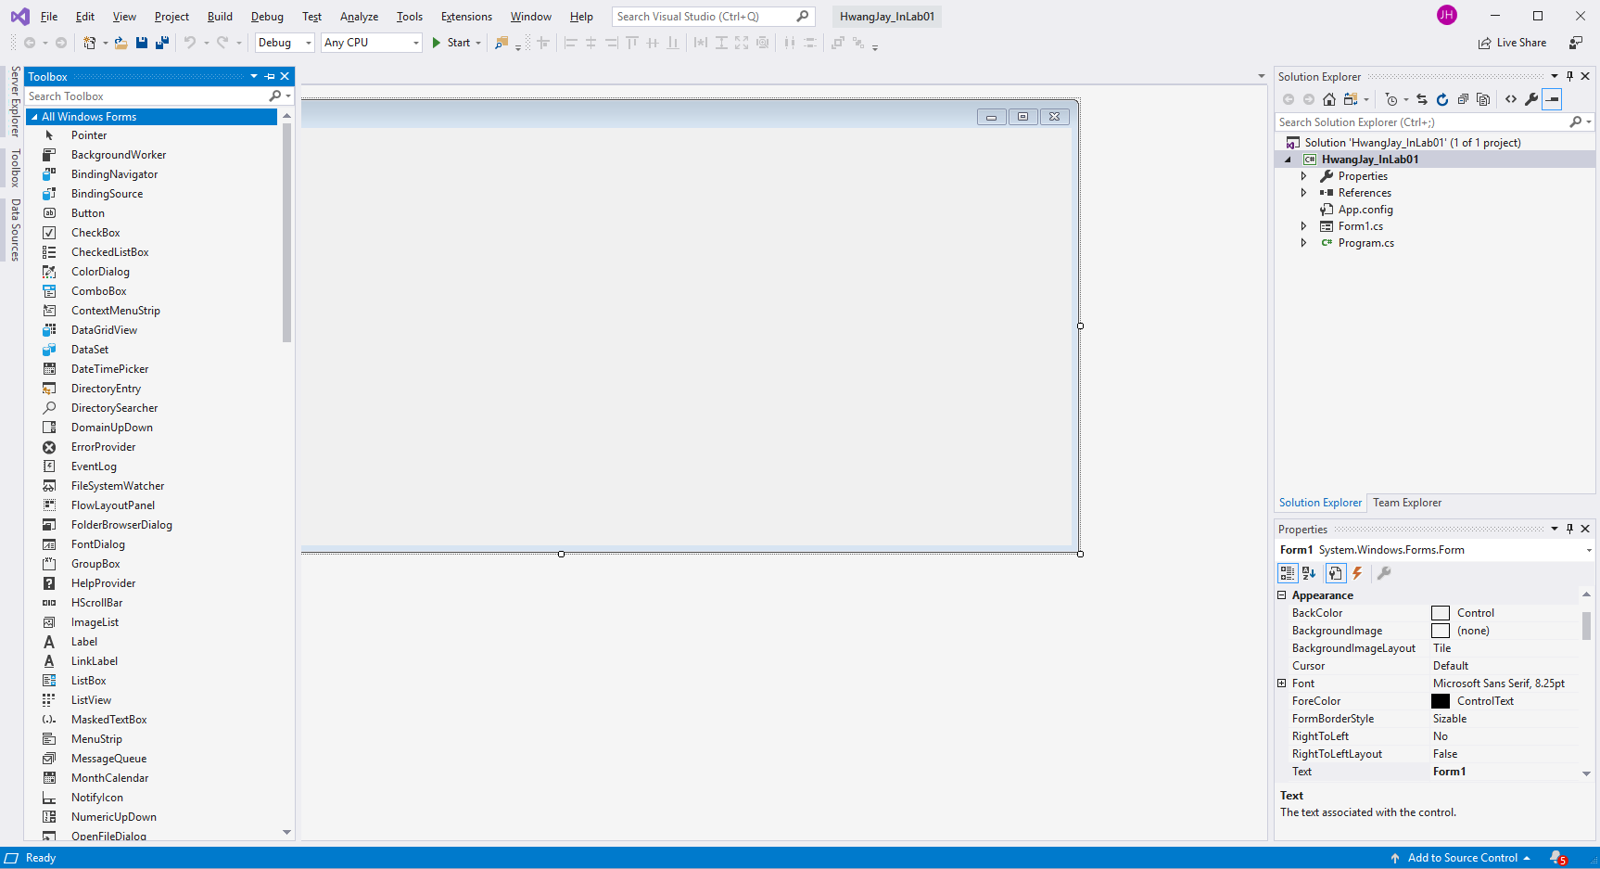

Figure 5 – A windows forms app created by Visual Studio 2019

Step 7. Once In_Labe01 is created, in the Solution Explorer Window (top right corner) double click on the *Form1.cs*, this will open up the *Form1.cs [Design]* tab where you can design the graphical user interface (GUI). Double click (or drag and drop) on the Button control located in the *ToolBox Window* (not shown here) under *Common Controls to place it on the Form.*

Step 8. Right click on the Button placed on the Form, click on Properties. In the Properties Window, change the Name property to *btnExit*, and the Text property to *Exit*.

Step 9. Double click on the Exit button. It will take you to the code window with the first line of the method and { } created. Type *Close( );* between braces as shown below:

private void btnExit_Click(object sender, EventArgs e)

{

Close();

}

Step 10. Complete the GUI requirement in *Figure2* by using the following options within Common Controls while abiding the acronym standards.

|  |  |
| --- | --- |
| Figure 6 - GUI for Step 10. | |
| GUI Objects | | Control | | Naming Standard | Text Property | Other Properties |
|  | | Label | | lbl | Full Name: |  |
|  | | Button | | btn | &Display | Name Property: btnDisplay |
|  | | Button | | btn | &Exit | Name Property: btnExit |
|  | | TextBox | | txt | none | Name Property: txtName |
|  | | TextBox | | txt | *none* | * Name Property: txtOutput * ReadOnly Property: True * Multiline Property: True |

Step 11. Click on the Start icon ***>*** on the toolbar to compile and run the project. The form will open up, with the Exit Button on the Form. Click on the Exit button, the project execution will end.

Step 12. Close the Inlab01 project. Now, zip the entire project as follows:

1. Browse your computer, find *In_Lab01* folder.
2. Right-click the ***outer*** folder in the red box.
3. Navigate to “*Send To*” then click “*Compressed(Zipped) folder*”
4. If unable to locate “*Compressed(Zipped) folder*”, then navigate and click “*7-Zip*”.
5. Then click “Add to your “LastnameFirstname_InLab01.Zip”.

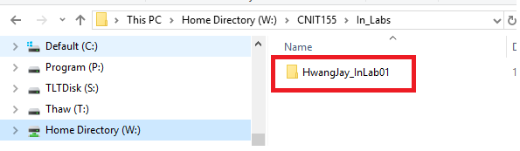

Figure 7 - InLabs folder path.

Submit the zipped folder to BB under the provided link.

For Electronic Submission, launch Blackboard > Click on *In_Labs* link > Click on *In_Lab01* Assignment > Click on Browse to locate the zipped folder and submit it.